CS 255 System Design Document Template

This template lays out all the different sections that you need to complete for Project Two. Each section has guidance to prompt your thinking. You will need to continually reference the interview transcript as you work to make sure that you are addressing your client’s needs. There is no required length for the final document. Instead the goal is to complete each section based on what your client’s needs are. Remove this note when you are finished, and replace all bracketed text with the relevant information.

UML Diagrams

UML Use Case Diagram

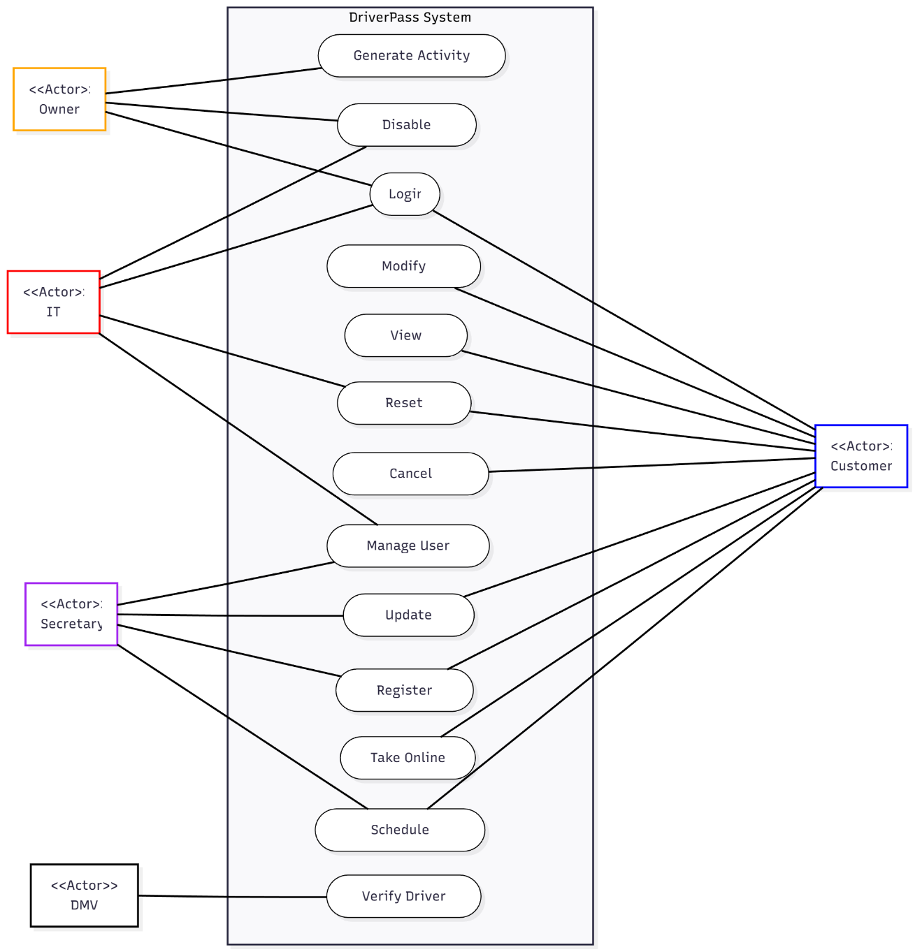

UML Activity Diagrams

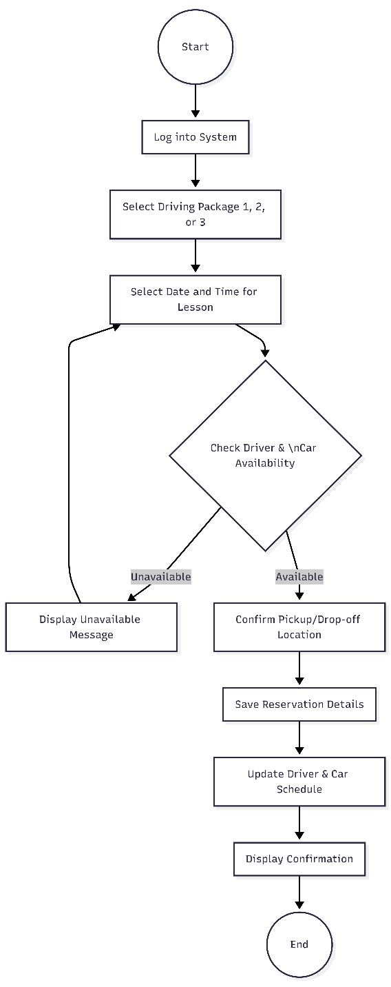
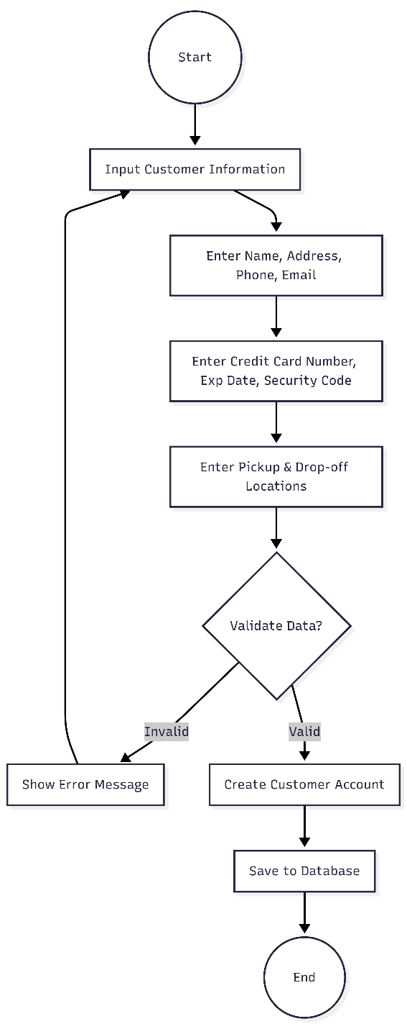

UML Sequence Diagram

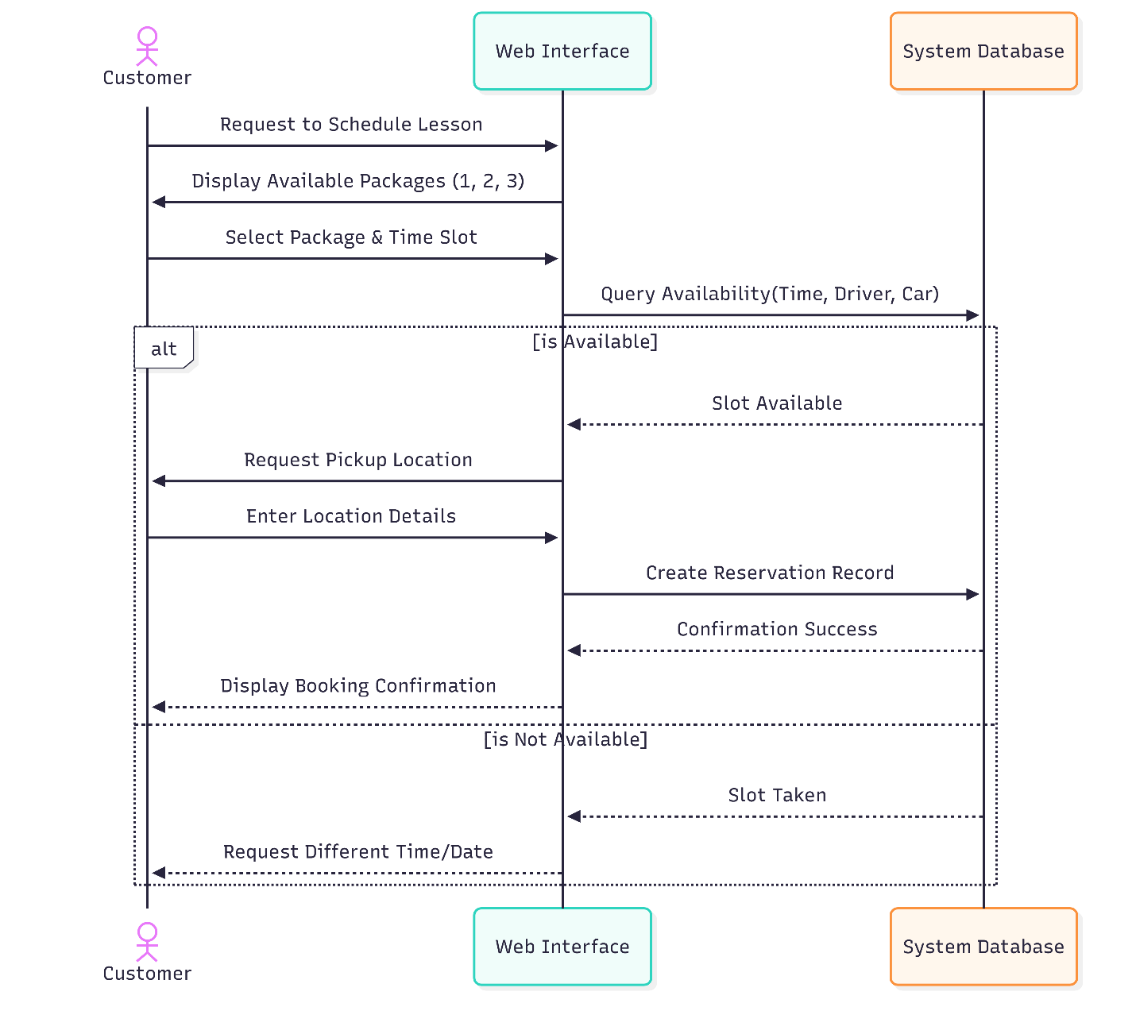

UML Class Diagram

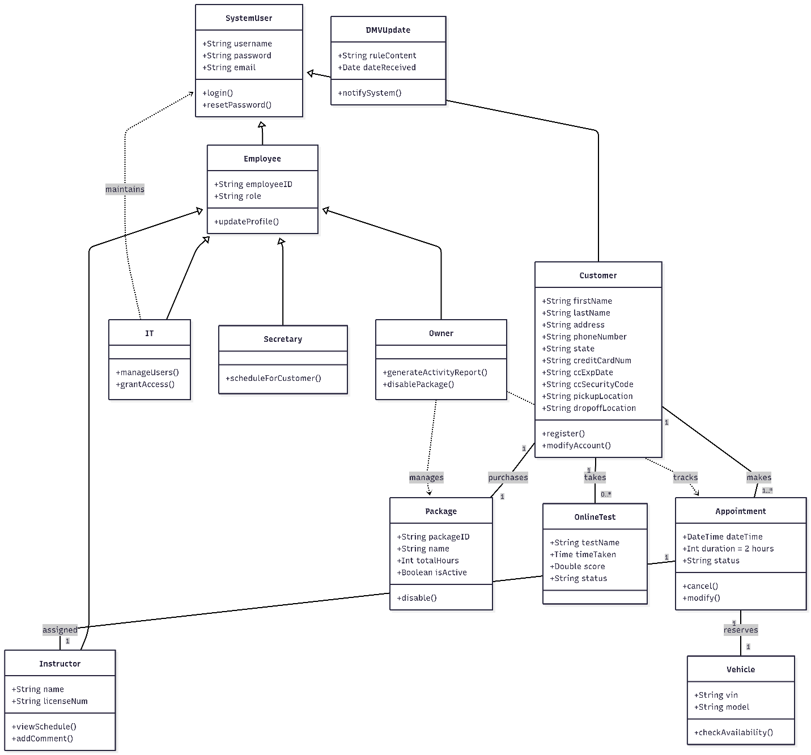

Technical Requirements

To support the DriverPass system, the technical design requires a robust client-server architecture that leverages cloud-based resources while strictly defining the necessary virtualized hardware. The primary hardware requirement involves deploying virtualized web servers and database servers capable of handling concurrent connections from multiple user types, including the owner, IT staff, secretaries, and customers. These server instances must possess sufficient processing power (CPU) and memory (RAM) to manage real-time scheduling, transaction processing, and the "cloud" hosting environment requested by the client. On the client side, the system must support a variety of physical hardware, specifically desktop computers and mobile devices, ensuring the owner can access data and reports from any location.
The software landscape for the system is built around a web-based application interface that runs on the server infrastructure and renders in standard web browsers. To manage the complex data relationships (such as linking customers to specific packages, instructors, and vehicles) the system requires a relational Database Management System (DBMS). This database software is critical for preventing data redundancy and ensuring data integrity across the various tables defined in the design. Additionally, the software stack must include an Application Programming Interface (API) integration layer to maintain a persistent connection with the DMV for receiving automated updates on rules and policies.

Regarding infrastructure and tools, the system relies on a secure cloud network to manage data backups and security protocols automatically, as the client explicitly requested to offload these maintenance tasks. This infrastructure must implement Secure Sockets Layer (SSL) or Transport Layer Security (TLS) encryption to protect sensitive transmission data, particularly credit card numbers and security codes entered during registration. For internal tools, the system requires a reporting engine capable of tracking user activity and generating logs for the owner. Finally, to satisfy the requirement for offline analysis, the system must include export tools that format reports for compatibility with external software like Microsoft Excel.

